Columbus findings using Connect RF’s CVA tool & RX Logger

We started the logging on 8 devices.

1. 2 – TC8000s – mainly used in the racking area called Reserve Storage High Bay.
2. 4 – WT6000s – mainly used in the pick tower and shipping pack lanes.
   1. 2 devices were in the bottom floor of the pick tower
   2. 2 devices were in the shipping pack lanes

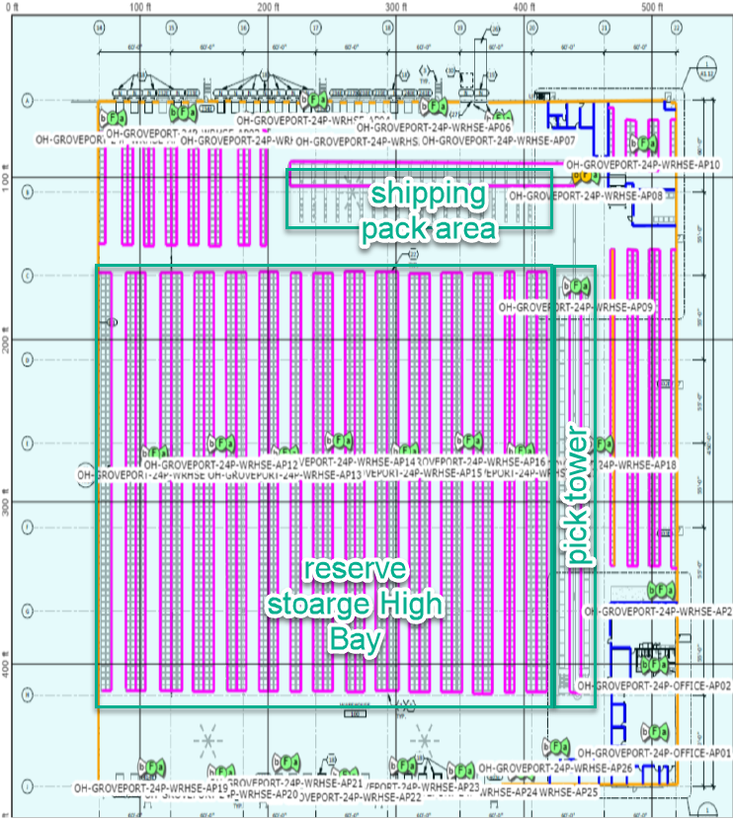

We would like to focus on three devices that were used in Reserve Storage High Bay (TC8000) and two in the Pick Tower(WT6000).

|  |  |  |  |  |
| --- | --- | --- | --- | --- |
| Device | IP Address | Serial # | Mac Address | RX Logger File Name |
| TC8000 | 10.2.128.144 | 18074521403554 | 94FB29253653 | BackupNow_190604_135511_3554.zip |
| WT6000 | 10.2.128.110 | 18015523026871 | 4083DEBD244C | BackupNow_190604_134248_6871.zip |
| WT6000 | 10.2.128.140 | 18015523026300 | 4083DEBD2529 | BackupNow_190604_134310_6300.zip |

** Log file attached to Email

Worked with Greg Kling (Connect RF). He provided the below information.

EVENT LOG  
  
NOTE: .144 did really bad (TC8000 - Reserve Storage High Bay)  
  
  
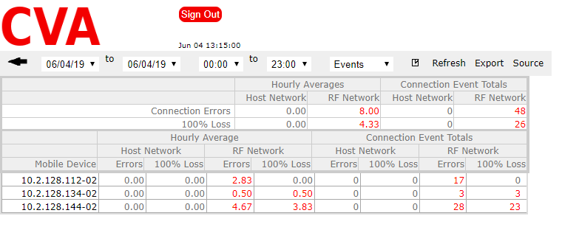  
10.2.128.144-02 is just loaded with errors and session restarts  
  
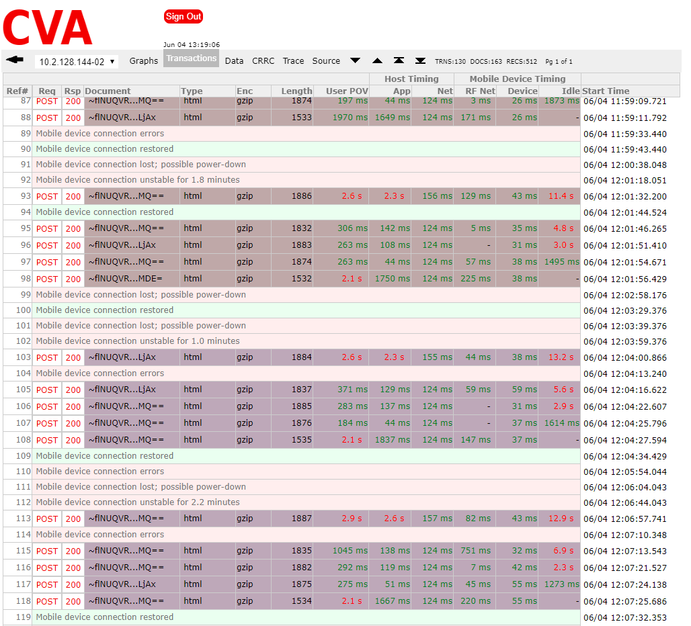  
Note: the times provided in the CVA can help to get to specific areas in the RXLogger files

EVENT LOG  
  
NOTE: 10.2.128.110 had more problems (WT6000 – Bottom Floor Pick Tower)  
  
This report is from the background pings we do every 5 seconds to the RF devices and host. We send 4 pings each time.  
  
 Error = returns 3,2 or 1 pings  
 100% loss = returns 0 pings  
  
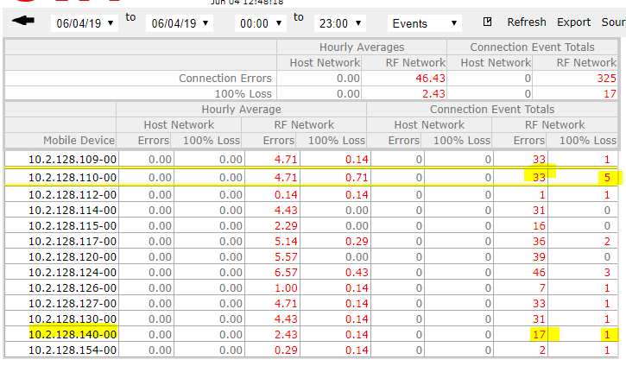  
Both have connection problems that lead to session restarts.  
 2 for 10.2.128.110-00   
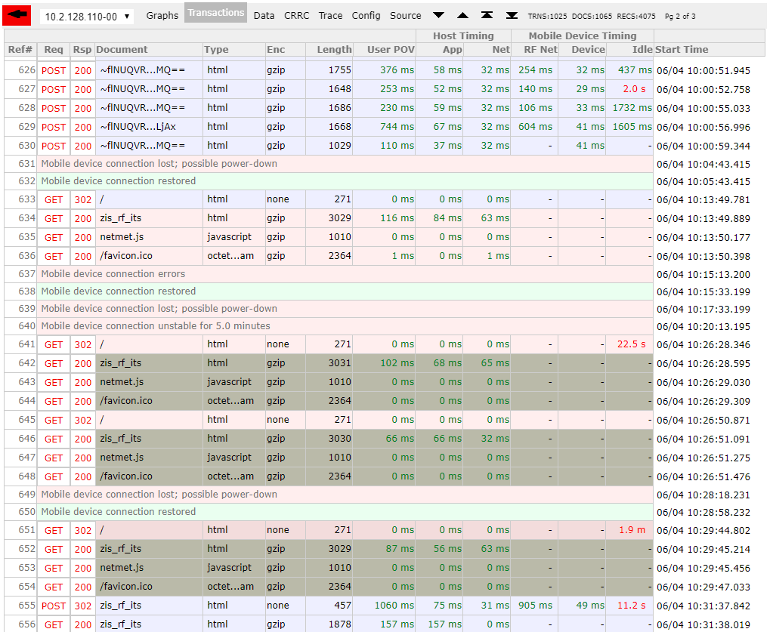  
Note: the times provided in the CVA can help to get to specific areas in the RXLogger files

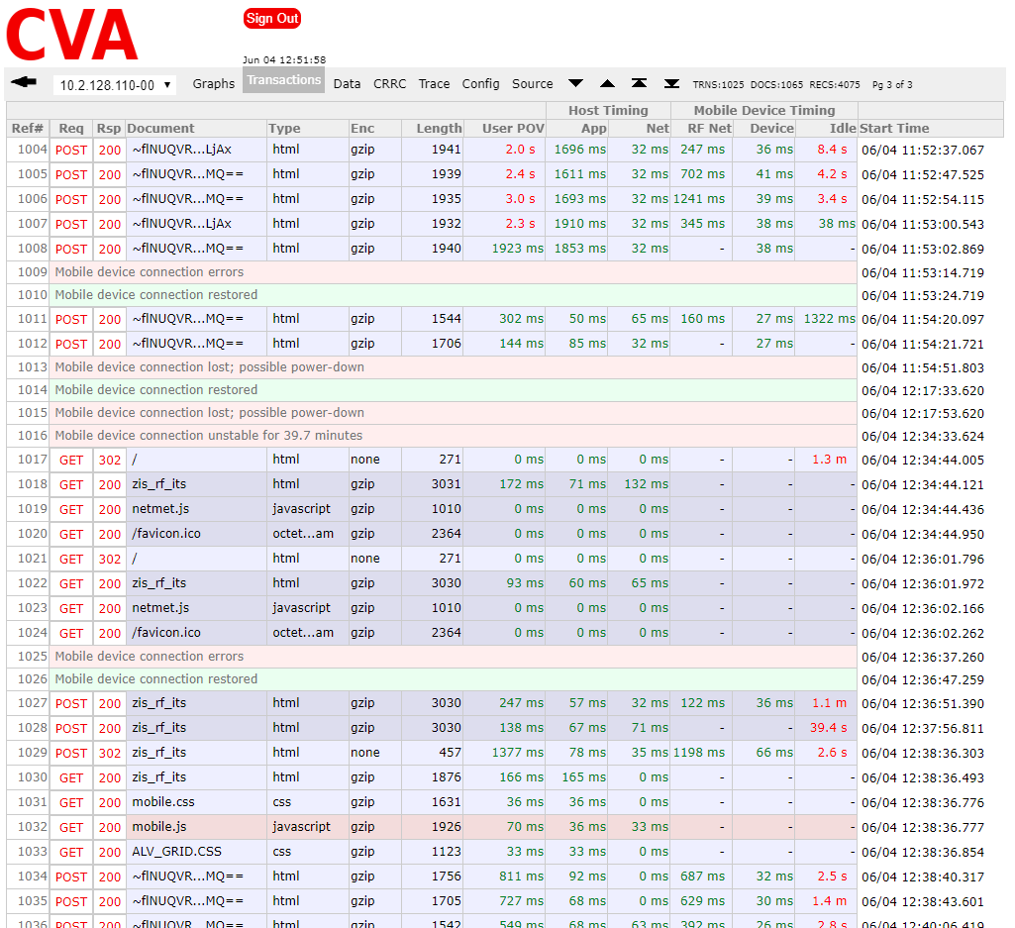

1 for 10.2.128.140-00   
